STAFF BULLETIN


Week Commencing 14 November 2011

HEAD’S FOCUS FOR THE WEEK: Please ensure that you are well prepared for Post 16 Evening and that you continue to promote your subject and the Sixth Form with our Year 11 students in your lessons and around the school

Assemblies: Form Tutors E – No assemblies Tuesday (SEN Controlled Assessments in West Hall)
VI Form Assembly: Miss K McEwan and Mr R Craig

SLT to meet daily at 8.30 am

OFF ROLL: Jared Cousins (Year 9)

ON ROLL: Danielle Wilson (Year 11)

Collective Act of Worship: Human Rights

All classroom bookings to be made through Cover Manager
All other room bookings to be made through Mrs H Frost

Mon 14/11/2011 Mrs L Gartley on course all day

Megan Hamblion – Primary GTP to visit – see details later in bulletin

Pd 1&2 Year 11 GCSE Maths Calculator Exam – Sports Hall

9.00am-12.15pm Interview for LRC post – interview panel: Mrs S Perkins, Mrs J Pepper and Mrs J Davies in LRC

9.15am Mr N Sydenham and Mr Chris Furniss to meet re ICT Strategy

10.00am–4.30pm Mrs H Frost and Mrs C Webster attending on-site Tucasi Schools Cash Office Lettings Administration training (Finance Office will be closed)

12.00pm Mr R Hodges to meet with Mr A Liddell re Performance Management Review

Pd 5 Mrs J Pepper to meet with Miss E King

1.45pm Year 10 & 11 Science Modules Exam – Sports Hall

2.45-4.30pm Product Design after school session – Mr A De Wet and Mr R Newsham

2.45pm TLC Meeting - B&E Conference Room

3.00pm NQT/GTP Meeting in Admin Meeting Room – Mr A Jacobs - Webportal

3.00-4.00pm Year 8-11 Writing Group – Mrs R Hodgson – BE4

4.00pm Mr R Hodges to meet with Chair and Vice Chair

6.00pm Curriculum Committee Meeting

Tue 15/11/2011 Mr D Emms on course all morning

Miss A Thyer on course all day

9.00am ECM meeting with Mr R Hodges, Mr A Draycott, Mr D Windeatt and Miss K Evans

9.00am Year 10 & 11 Science Modules Exam – Sports Hall

9.30am Mrs L Harper to meet with Rani Juttla Internal Verifier

10.00-11.30am Computers for Beginners – Lesley Evans – B&E Conference Room

10.00am Mrs H Frost to meet with Paul Marsh of Nat west Bank Plc

2.15pm Mr R Hodges to meet Canon Jane Freeman (St Andrew’s Church)

2.45-4.00pm Young Apprentice Programme – Mr R Merry, Mrs N Niner and Mrs S Acton – H1, H2 & PC5

2.45pm BTEC Fish Husbandry – DT2

2.45-3.45pm Glee Club – Drama

2.45-3.45pm Aladdin Rehearsals – Mr D Carlton and Miss H Boyce –
Drama 1 & 2

3.00pm Church Representatives Meeting - Admin Meeting Room

6.00-7.30pm Introduction to Psychology – BE3 – Mrs G Craig

6.00-7.30pm Introduction to Web Design – PC2 – Mr M Oakshott

Wed 16/11/2011 Yr 8-11 Interim reports Subject Leaders Deadline

Yolanda Railton, Film Studies Tutor for Ndtl to visit AS and A2 Film Studies students

Mrs N Niner and Mr A Jacobs on course all day

8.30am Staff briefing – B&E Conference Room

Pd 1&2 French Controlled Assessment – Sports Hall

Pd 3 Mr M Harper to observe Miss S Kemp (NQT obs)

1.10-1.45pm Chill-Out lunch time club – B&E Conference Room

1.45pm GCSE Geography Practice Exam – Sports Hall

3.00pm Mrs W Reading to conduct a one hour training session for Yr 9 Tutors on “Fast Tomato” careers matching programme – PC4

3.00pm Mr M Harper to meet with Mr A De Wet and Mr R Newsham re Product Design Tracking

7.00pm Post 16 Evening – Presentation in West Hall - Subject Stands in East Hall and LP rooms – see details later in bulletin

Thu 17/11/2011 Mr M Harper and Mr S Ansell on course all day

8.15am -4.00pm Mrs S Acton to accompany Daniel Frost, Daniel Rose, Billy Dines, Emily Arthur and Tahifiza Hannan to attend a “Lions’ Lair Challenge” at Westcliffe High School

Pd 1-4 Managing my Emotions course – Mr A Cullers

Pd 1&2 English Controlled Assessment – Sports Hall

9.55am-1.00pm Mr D Windeatt and Mr S Clayton to visit SEC Basildon

Pd 4 Miss E King to observe Miss R Draycott

1.45pm Miss A Thyer on course

2.00-3.00pm Mr R Hodges to meet Karen Kerridge - SIPP

2.45-3.45pm Aladdin Rehearsals – Mr D Carlton, Miss H Boyce and Miss A Thyer – Drama 1 & 2

2.45-4.30pm Product Design after school session – Mr A De Wet

2.45-3.45pm BTEC Health and Social Care – Mrs G Craig

2.45pm Sixth Form Committee Meeting

3.00-4.00pm Year 12&13 Reading Group – Mrs R Hodgson - Library

3.15pm SLT meeting – including Ebacc tracking and monitoring

Fri 18/11/2011 Mrs N Niner and Mrs J Pepper on course all day

Children in Need day – non uniform

Pd 1 Mr M Harper to observe Mrs C Boulton (NQT obs)

10.00am-12.00pm Mr R Hodges, Mrs M Beauchamp, Mr W Hawkins and Mrs A Cash to meet Karen Kerridge - SIPP

2.45-4.30pm Product Design after school session – Mr R Newsham

Registration – Year 7-11 students to complete weekly achievement sheets

Gold and White 100% punctuality stickers to be issued by tutors at Friday registration (any staff who need more please see General Office)

Form Tutor Monitoring Sheets (Upper School to Mr D Windeatt and Lower School to Mr P Mower) by 3.00pm

HOY Weekly HW diary monitoring sheets due to HOUS/HOLS by 3.00pm

6.00pm Mr R Craig to attend Duke of Edinburgh training weekend

Room Bookings

 | B&E Conf Room | B&E Board Room | West Hall | West Dining Area | Interview Room
Monday |  | Pd 1 A2 Film Studies
Tuesday |  | Pd 1 AS Film Studies |  |  | Pd 2 Sarah Pattinson (YOT)
Wednesday | Chill-Out club – lunch time
Thursday
Friday

HOLIDAY LIST
Wren | Cripps | 9 - 09B | 07-Nov-11 | 18-Nov-11
Jessica | Maisey | 7-11B | 09-Nov-11 | 16-Nov-11
Amber | Hellier | 10-08A | 10-Nov-11 | 11-Nov-11
Adam | Walter | 12B | 11-Nov-11 | 11-Nov-11
Katy | Walter | 7-11M | 11-Nov-11 | 11-Nov-11
Adam | Beeson | 12E | 18-Nov-11 | 21-Nov-11

ATTENDANCE PUNCTUALITY

Week commencing 31 October 2011 Week commencing 31 October 2011
Yr 7 11E 99.3% Yr 7 11E 100%
Yr 8 10H 100% Yr 8 10C 100%
Yr 9 09P 96.9% Yr 8 10P 100%
Yr 10 08A 94.3% Yr 8 10U 100%
Yr 11 07A 97.1% Yr 10 08B 100%

STUDENTS ON REPORT
Year 7 | None | Year 10 | Billy Murphy  Stephanie Long
Year 8 | None | Year 11 | Chantelle Taylor on report to DWi  Calum Fitzpatrick - progress/effort report  Callum Gazzard - progress/effort/homework  Dan Daines - progress/effort/behaviour/ homework  Josh Carter (effort, behaviour, progress and homework)
Year 9 | None

Monday 14 November - Megan Hamblion - GTP Primary from Essex ITT
Arrive 9.30 – Meet with Mr C Carrott ITT Coordinator and HOY 8
Period 2 – English in A5 with Miss M Gladen
Period 3 – 7MaX1 H2 with Mr P Mower
Period 4 - 7B Business Studies H4 with Miss N Niner
Period 5 – 7B Art Art3 with Mrs L Lucking

Post 16 Evening – 16 November 2011

3.00pm Buffet for staff involved in the Sixth Form Open Evening in the B& E Conference Room

4.30pm Staff can start setting up their subject stands for the Sixth Form Open Evening.

7.00 – 7.20 Welcome and Presentation with A Liddell , K McEwan, Joe Rose and James Woods

7.20 – 9.00 Students and Parent to tour subject stands in the East Hall and Sixth Form Suite

Staff to take all materials from their subject stands away with them as the rest of the school will be locked up. If anyone needs to lock anything away please see Karen McEwan or Rob Craig at the end of the event and any valuables can be locked in their offices.

Sixth Form Open Evening Layout

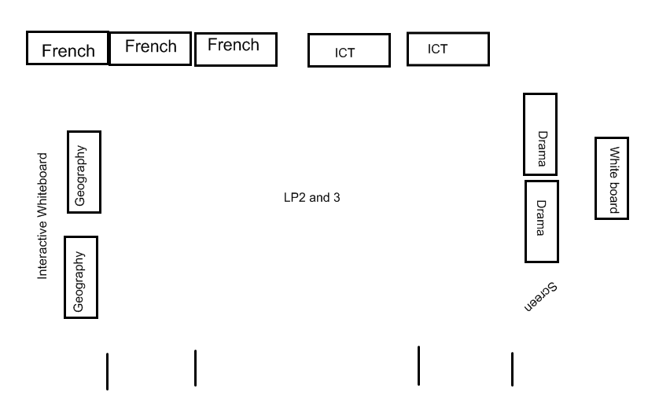

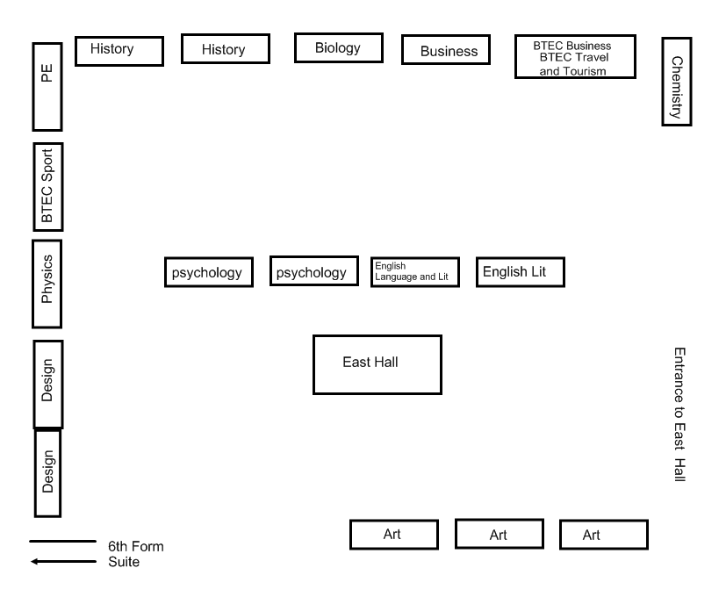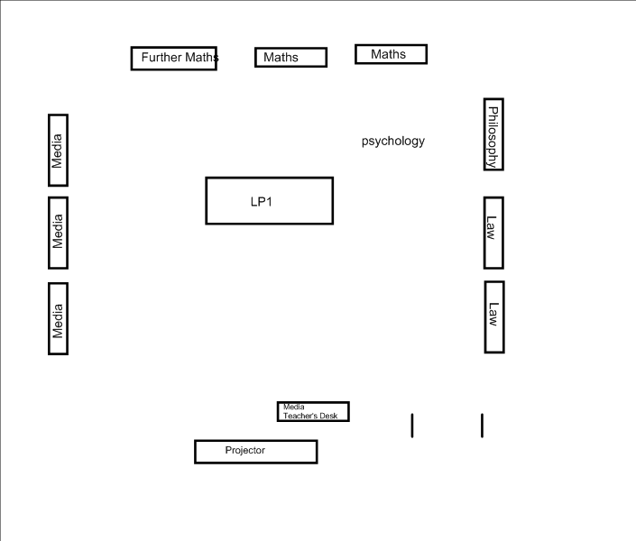

COLLECTIVE ACT OF WORSHIP
Week Beginning
14 November 2011

HUMAN RIGHTS

“Human rights are fundamental to our nature; without them we cannot live as human beings”

(UN Office of Information)

What is meant by Human Rights”

Why can we not live without Human Rights?

“Children should have a right to an education”

(Declaration of Children’s Rights) (UN)

Why is education so important?

Find out about the United Nations Declaration of Human Rights.

“Each individual is truly a person with a nature that is endowed with intelligence and free will, and rights and duties are universal and inviolable”

(Pope John XXIII)

What rights do you think we should have as human beings?

Why is it especially important to ensure that children’s rights are not abused?

DETENTIONS RECORD
NAME |  | SEX | TG | REASON | STAFF | DATE
YEAR 7
HALL | Oliver | M | 11U | Missed detention set for 2/11 fro homework not completed | Aco | 09/11/2011
YEAR 8
GARDINER | Reece | M | 10C | No planner, not signed | JSi | 11/11/2011
HULL | Ben | M | 10C | Persistent lack of organisation, planner not signed and lost | JSi | 11/11/2011
MERRITT | George | M | 10C | No planner, not signed, numerous warnings | JSi | 11/11/2011
THURLING | Ellie | F | 10C | Not having planner signed | JSi | 11/11/2011
YEAR 9
ABBOTT | Daniel | M | 09B | Misbehaving in lesson and missing previous detention | RMe | 07/11/2011
COOK | Bobbie | F | 09C | No h/wk | Mcu | 11/11/2011
LATCHFORD | Jack | M | 09C | No h/wk | Mcu | 11/11/2011
MCGONNELL | Danny | M | 09C | Disrupting class | Mcu | 07/11/2011
CRITTENDEN | Johnny | M | 09E | Did not turn up for lunchtime detention, 1 hour with Miss Evans | Kev | 10/11/2011
DEMETRIOU | Nicole | F | 09H | Disruptive | Sfo | 11/11/2011
DEMETRIOU | Nicole | F | 09H | No h/wk | Mcu | 11/11/2011
MCELVENNY | Joe | M | 09H | Disruptive & missed detention | SKe | 11/11/2011
HIGGINS | Tom | M | 09M | Misbehaving in lesson and missing previous detention | Rme | 07/11/2011
HIGGINS | Tom | M | 09M | 5 x lates wk beg 31/10/11 | Esm | 09/11/2011
MILLS | Christopher | M | 09M | 3 x lates wk beg 31/10/11 | Esm | 09/11/2011
O'NEILL | Tomy | M | 09M | Disruptive & missed detention | Ske | 11/11/2011
CROSSLEY | Amy | F | 09P | Being rude in class | CMa | 08/11/2011
CROSSLEY | Amy | F | 09P | Sent out of the classroom for talking and disrupting the lesson | Ibu | 07/11/2011
ESLER | Remi | F | 09P | Refusing to follow instructions | CMa | 08/11/2011
LUMBARD | Rosie | F | 09P | Not turning up to lunch time detention and for no reading book | Jsi | 11/11/2011
TUGBY | Sophie | F | 09P | Not turning up to lunch time detention and for no reading book | Jsi | 11/11/2011
HANNABUSS | Billy | M | 09U | Misbehaving and acting around in detention | RMe | 08/11/2011
MARSH | Craig | M | 09U | Refusing to follow instructions | CMa | 08/11/2011
MARSH | Craig | M | 09U | Sent out of the classroom for talking and disrupting the lesson | IBu | 07/11/2011
YEAR 10
RENDER | Lewis | M | 08A | Poor behaviour | NSy | 07/11/2011
RENDER | Lewis | M | 08A | Poor behaviour | NSy | 09/11/2011
RENDER | Lewis | M | 08A | Poor behaviour | NSy | 11/11/2011
SUMNER | Lauren | F | 08A | Rude, disrupting lesson | Mcu | 11/11/2011
BARRASS | Andrew | M | 08B | No Maths h/wk | CTi | 10/11/2011
PATTINSON | Rhiannon | F | 08B | No homework | CLm | 11/11/2011
PEARTON | Kellen | M | 08B | No Maths h/wk | CTi | 10/11/2011
EVANS | Caitlin | F | 08C | No homework | MCu | 11/11/2011
GOUGH | Joseph | M | 08E | No homework | MCu | 11/11/2011
MOONEY | George | M | 08E | Interrupting, lunch time detention | SFo | 11/11/2011
MOONEY | George | M | 08E | Continual interruptions | SFo | 11/11/2011
FIELD | Joe | M | 08H | Interrupting | SFo | 11/11/2011
MARSH | Drew | M | 08H | Continual interruptions and chewing | SFo | 11/11/2011
MARSH | Drew | M | 08H | Interrupting, lunch time detention | SFo | 11/11/2011
MURPHY | Billy | M | 08H | Continual interruptions | SFo | 11/11/2011
MURPHY | Billy | M | 08H | Interrupting, lunch time detention | SFo | 11/11/2011
CHALMERS | Jaime | F | 08M | 3 x lates wk beg 31/10/11 | GCr | 10/11/2011
CHALMERS | Jaime | F | 08M | Poor behaviour | Cti | 10/11/2011
CHALMERS | Jaime | F | 08M | Missing P5 lesson | Nsy | 11/11/2011
DUNCAN | Nicholas | M | 08M | Inappropriate behaviour | NSy | 07/11/2011
DUNCAN | Nicholas | M | 08M | Inappropriate behaviour | NSy | 09/11/2011
DUNCAN | Nicholas | M | 08M | Inappropriate behaviour | NSy | 11/11/2011
HARRIS | Joe | M | 08M | 3 x lates wk beg 31/10/11 | GCr | 10/11/2011
TOVEY | Ross | M | 08M | Continual interruptions | SFo | 11/11/2011
TOVEY | Ross | M | 08M | Chewing, not following instructions out of his chair, disruptive, lunch time detention | SFo | 11/11/2011
GAULD | Alex | M | 08P | Off task | SFo | 11/11/2011
GROUND | Connor | M | 08P | No homework | Mcu | 11/11/2011
LONG | Steph | F | 08P | No homework | CLm | 11/11/2011
RYAN | Ben | M | 08P | Continual interruptions | SFo | 11/11/2011
RYAN | Ben | M | 08P | Interrupting, lunch time detention | SFo | 11/11/2011
SIM-JONES | Denni | F | 08P | No Maths h/wk | CTi | 10/11/2011
SIM-JONES | Denni | F | 08P | Missed detention | CTi | 08/11/2011
ALLNUTT | Charmian | F | 08U | 3 x lates wk beg 31/10/11 | GCr | 10/11/2011
BUDD | Ryan | M | 08U | No homework | MCu | 11/11/2011
GOWER | Casey | M | 08U | No homework | MCu | 11/11/2011
HART | Harrison | M | 08U | No homework | Mcu | 11/11/2011
KEELEY | Luke | M | 08U | Refusing to do any work | Mcu | 10/11/2011
KNIGHT | Bradley | M | 08U | No homework | MCu | 11/11/2011
WALDOCK | Michael | M | 08U | Disrupting lesson | MCu | 11/11/2011
WITHAM | Chloe | F | 08U | No Maths h/wk | CTi | 10/11/2011
YEAR 11
FOX | Connor | M | 07A | Not turning up to detention for lack of coursework | MLg | 09/11/2011
GREEN | Bradley | M | 07A | Not turning up to detention for lack of coursework | MLg | 09/11/2011
HOCKLEY | Abigail | F | 07A | Coursework catch-up | MLg | 08/11/2011
HOCKLEY | Abigail | F | 07A | Failing to attend detention for missing homework | MLg | 09/11/2011
EARL | Jordan | M | 07B | Not turning up to detention for lack of coursework | MLg | 09/11/201
GIBSON | Jack | M | 07E | Not turning up to detention for lack of coursework | MLg | 09/11/2011
HAINES | Chelsea | F | 07E | Not turning up to detention for lack of coursework | MLg | 09/11/2011
LAWRENCE | Liam | M | 07E | 4 x lates wk beg 31/10/11 | MSp | 10/11/2011
HUNT | Grace | F | 07H | Missed previous detention | RMa | 10/11/2011
LITTLE | Matthew | M | 07H | Being disruptive, throwing custard creams in class and walking out when asked to stay behind | CLm | 11/11/2011
LIPLEY-HINTON | Renee | F | 07M | 3 x lates wk beg 31/10/11 | MSp | 10/11/2011
WRIGHT | Max | M | 07M | Not turning up to detention for lack of coursework | MLg | 09/11/2011
HILLS | Alice | F | 07P | Lack of coursework and failing to follow instructions and skipping classes | MLg | 09/11/2011
PEACHEY | Chloe | F | 07P | Missed previous detention | RMa | 10/11/2011
TOVEY | Parys | F | 07P | Talking after warning for behaviour. Refusing to move when the order was given | RMa | 07/11/2011
TOVEY | Parys | F | 07P | Inappropriate use of the Internet | Nsy | 10/11/2011
HERRIDGE | Courtney-Jane | F | 07U | Not turning up to detention for lack of coursework | MLg | 09/11/2011

